Jack Cardwell

11/17/14

Professor Farid

Computer Science 1

Short Assignment 8

1.

|  |  |  |  |  |  |
| --- | --- | --- | --- | --- | --- |
| a | b | c | (a*b) | (a*c) | (a*b)+(a*c) |
| 0 | 0 | 0 | 0 | 0 | 0 |
| 0 | 0 | 1 | 0 | 0 | 0 |
| 0 | 1 | 0 | 0 | 0 | 0 |
| 0 | 1 | 1 | 0 | 0 | 0 |
| 1 | 0 | 0 | 0 | 0 | 0 |
| 1 | 0 | 1 | 0 | 1 | 1 |
| 1 | 1 | 0 | 1 | 0 | 1 |
| 1 | 1 | 1 | 1 | 1 | 1 |

|  |  |  |  |  |
| --- | --- | --- | --- | --- |
| a | b | c | (b+c) | a*(b+c) |
| 0 | 0 | 0 | 0 | 0 |
| 0 | 0 | 1 | 1 | 0 |
| 0 | 1 | 0 | 1 | 0 |
| 0 | 1 | 1 | 1 | 0 |
| 1 | 0 | 0 | 0 | 0 |
| 1 | 0 | 1 | 1 | 1 |
| 1 | 1 | 0 | 1 | 1 |
| 1 | 1 | 1 | 1 | 1 |

|  |  |  |  |  |
| --- | --- | --- | --- | --- |
| a | b | c | (b*c) | a+(b*c) |
| 0 | 0 | 0 | 0 | 0 |
| 0 | 0 | 1 | 0 | 0 |
| 0 | 1 | 0 | 0 | 0 |
| 0 | 1 | 1 | 1 | 1 |
| 1 | 0 | 0 | 0 | 1 |
| 1 | 0 | 1 | 0 | 1 |
| 1 | 1 | 0 | 0 | 1 |
| 1 | 1 | 1 | 1 | 1 |

2. If you switched from (a*b)+(a*c) to a*(b+c), you would save 2N transistors because you are getting rid of one of the “and” gates. Both “and” gates and “or” gates use two transistors. “Not” gates use one transistor and one resistor. “Or” gates have transistors in parallel, while “and” gates have transistors in series.

3. The simpler expression is a+(b*c), as shown by the truth tables below.

|  |  |  |  |  |  |
| --- | --- | --- | --- | --- | --- |
| a | b | c | (a+b) | (a+c) | (a+b)*(a+c) |
| 0 | 0 | 0 | 0 | 0 | 0 |
| 0 | 0 | 1 | 0 | 1 | 0 |
| 0 | 1 | 0 | 1 | 0 | 0 |
| 0 | 1 | 1 | 1 | 1 | 1 |
| 1 | 0 | 0 | 1 | 1 | 1 |
| 1 | 0 | 1 | 1 | 1 | 1 |
| 1 | 1 | 0 | 1 | 1 | 1 |
| 1 | 1 | 1 | 1 | 1 | 1 |

4. Because we got rid of one “or” gate, we don’t need to use 2 transistors for each combination of a, b, and c. Therefore, the new equation would save 2N transistors.

5. NAND Gate

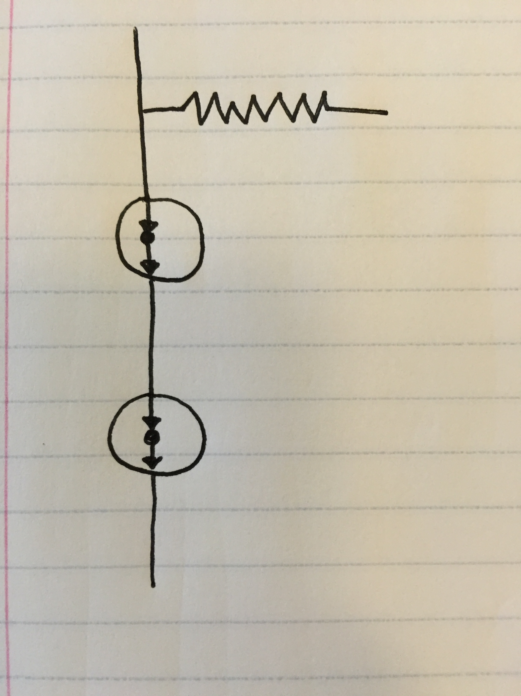

6.

|  |  |  |  |
| --- | --- | --- | --- |
| a | b | c | Output |
| 0 | 0 | 0 | 0 |
| 0 | 0 | 1 | 0 |
| 0 | 1 | 0 | 0 |
| 0 | 1 | 1 | 1 |
| 1 | 0 | 0 | 0 |
| 1 | 0 | 1 | 1 |
| 1 | 1 | 0 | 1 |
| 1 | 1 | 1 | 1 |

Sub-Expressions

Output1=a’bc

Output2=ab’c

Output3=abc’

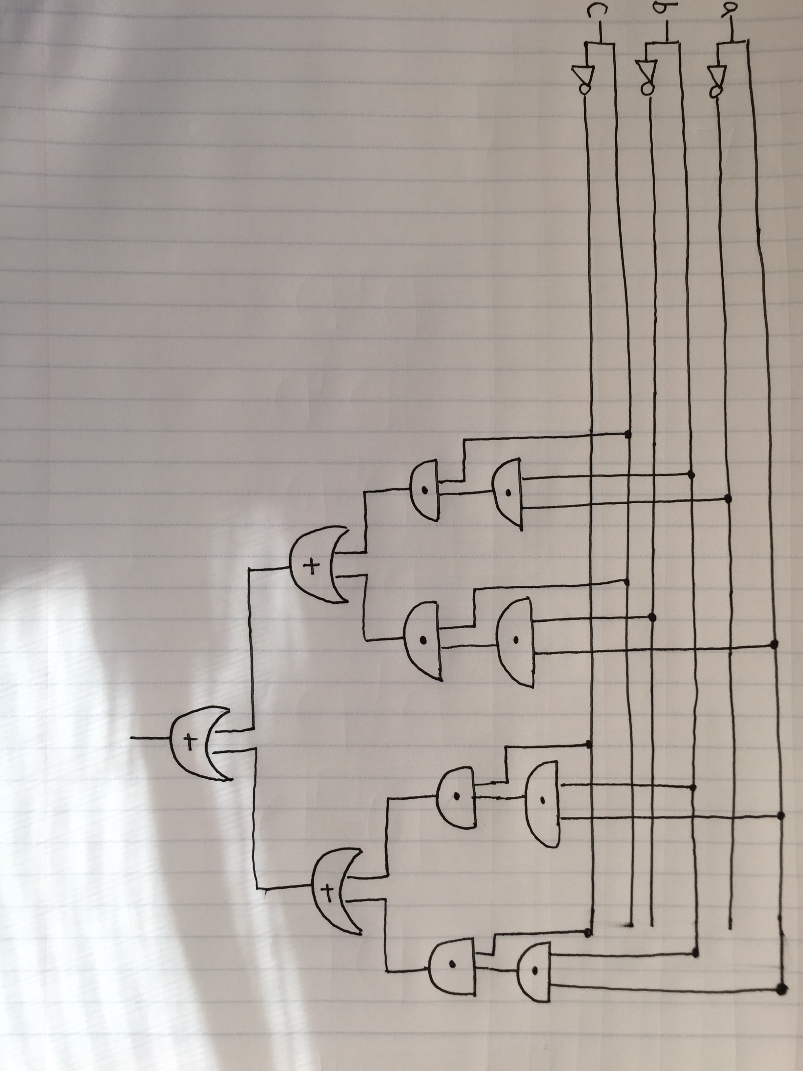Output4=abc

Final Boolean Expression=(a’bc)+(ab’c)+(abc’)+(abc)

7.

|  |  |  |  |  |  |  |  |  |  |  |
| --- | --- | --- | --- | --- | --- | --- | --- | --- | --- | --- |
| a | b | c | D0 | D1 | D2 | D3 | D4 | D5 | D6 | D7 |
| 0 | 0 | 0 | 1 | 0 | 0 | 0 | 0 | 0 | 0 | 0 |
| 0 | 0 | 1 | 0 | 1 | 0 | 0 | 0 | 0 | 0 | 0 |
| 0 | 1 | 0 | 0 | 0 | 1 | 0 | 0 | 0 | 0 | 0 |
| 0 | 1 | 1 | 0 | 0 | 0 | 1 | 0 | 0 | 0 | 0 |
| 1 | 0 | 0 | 0 | 0 | 0 | 0 | 1 | 0 | 0 | 0 |
| 1 | 0 | 1 | 0 | 0 | 0 | 0 | 0 | 1 | 0 | 0 |
| 1 | 1 | 0 | 0 | 0 | 0 | 0 | 0 | 0 | 1 | 0 |
| 1 | 1 | 1 | 0 | 0 | 0 | 0 | 0 | 0 | 0 | 1 |

D0=a’b’c’

D1=a’b’c

D2=a’bc’

D3=a’bc

D4=ab’c’

D5=ab’c

D6=abc’

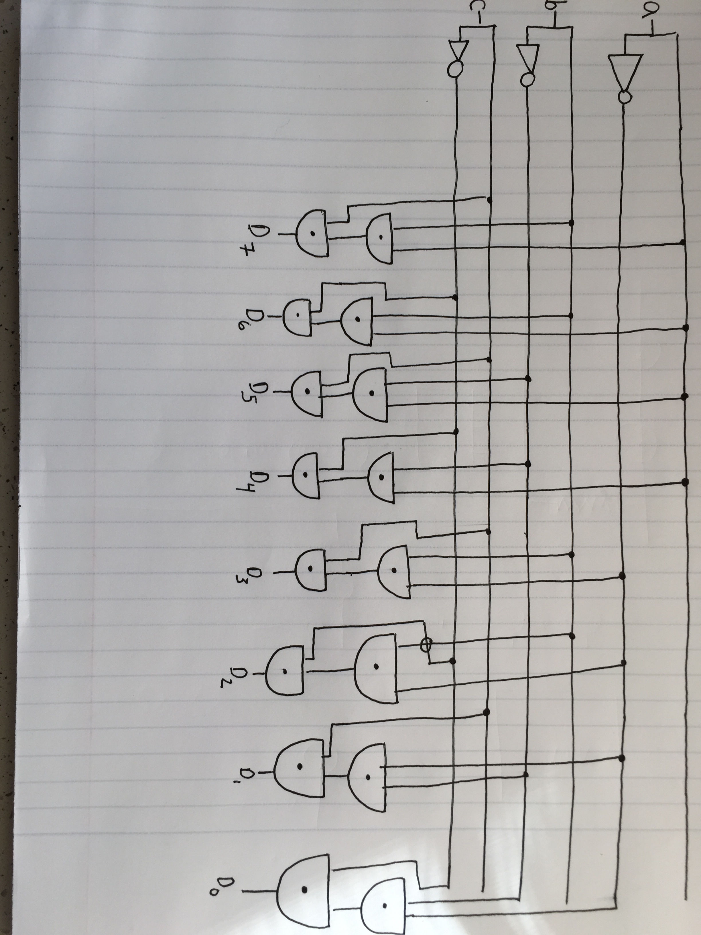D7=abc

Since we only care about the eight individual outputs, there is no need to combine the expressions above. The final Boolean expression is the set of equations outlined above.